Autonomous Driving: Driver Assistance/Training Module #2

*Sensor & pixy cam*

Jingwen Mo

Supervised by Prof. Quoc-Viet Dang

July 10th, 2018

# Introduction

Pixy is a fast vision sensor for DIY robotics and similar applications. You can teach Pixy an object just by pressing a button. When we can connect it to Arduino, we can do a lot of staff. We use Pixy cam to watch an orange object. If it gets close to our vehicle, we can open the ultrasonic sensor to detect the distance between the object and our vehicle which tells us whether we are close or too far away. This approach prevents the effects of interference on the sensor, which has many practical applications.

# Testing Environment

I have set 3 positive test cases and 3 negative test cases for driver assistance/training module

## Acceptable situation

### Green light test

When the object is standing and very close to our vehicle ( less than 10 cm), the ultrasonic sensor will sense the distance and turn the green light on.

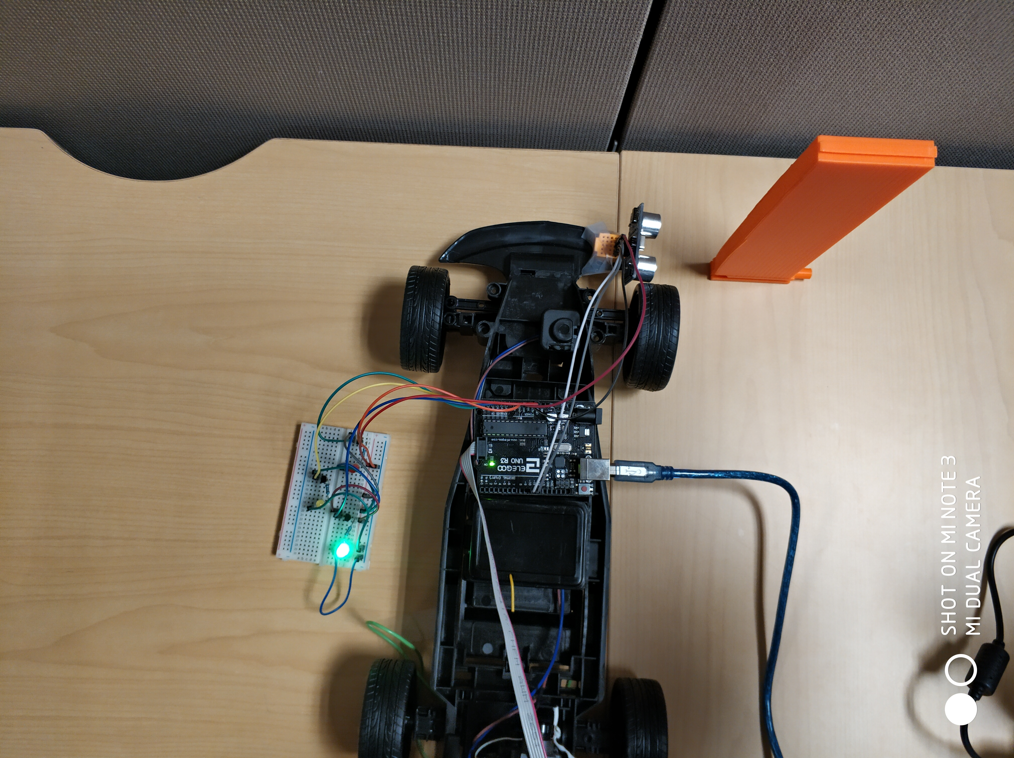

We can see that the distance is around 7cm,

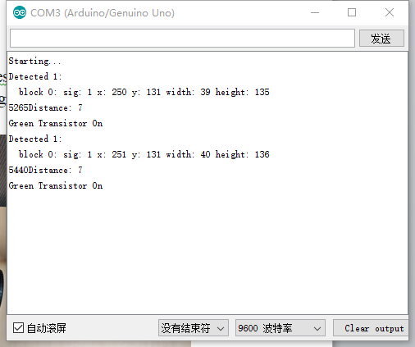

terminal output-GL

And this is what pixy sees.

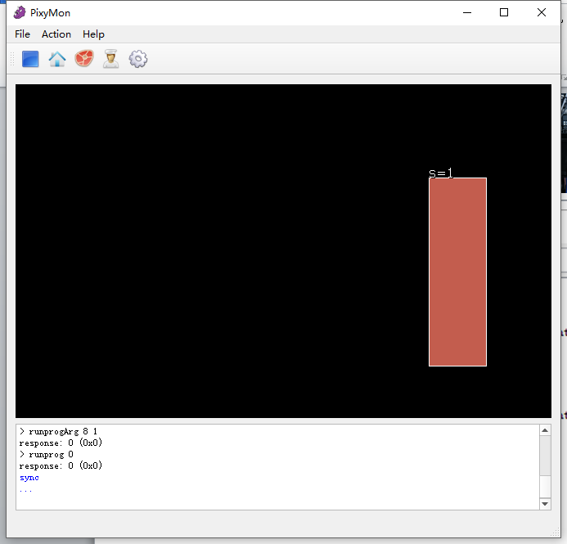

Pixy cam vision-GL

### Yellow light test

When the object is standing and close to our vehicle( less than 30 cm and more than 10 cm), the ultrasonic sensor will sense the distance and turn the yellow light on.

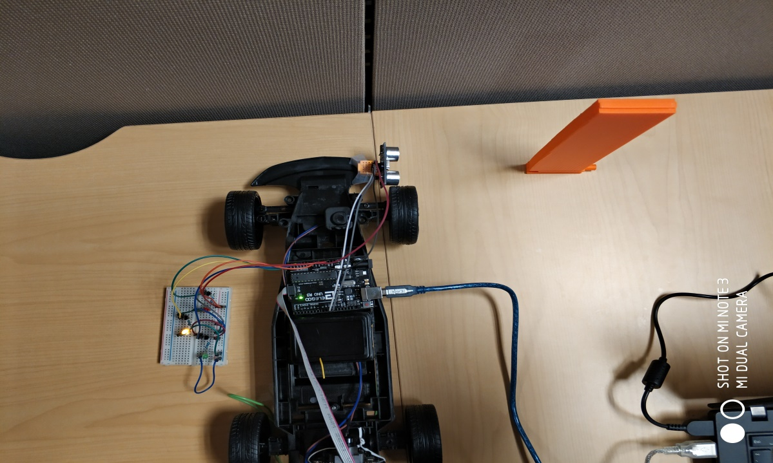

We can see that the distance is around 16cm,

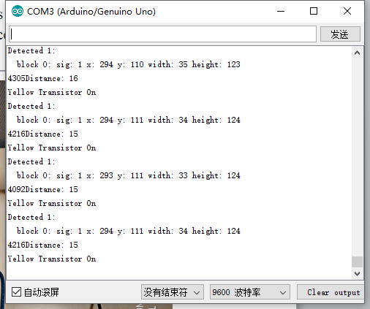

terminal output-YL

And this is what pixy sees.

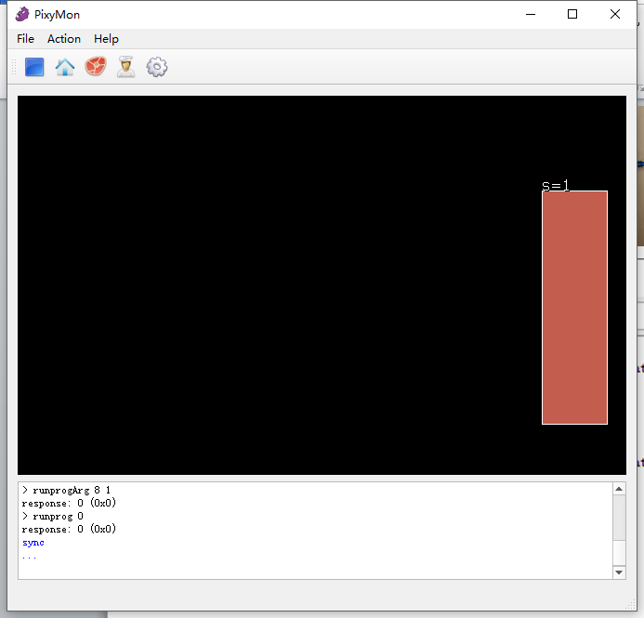

Pixy cam vision-YL

### Red light

Theoretically, when the object is a little far from our vehicle( more than 30 cm and less than 60 cm), the red light will be turned on. However, due to the limit of the pixy cam vision scope, which I will talk about later, this cannot work. In order to show you how this system works, I rearrange the 3 different ranges (0 to 6: Green light; 7 to 12: Yellow light; 13 to 19: Red light).

After this change, we can see that red light is turned on when the distance is 14cm

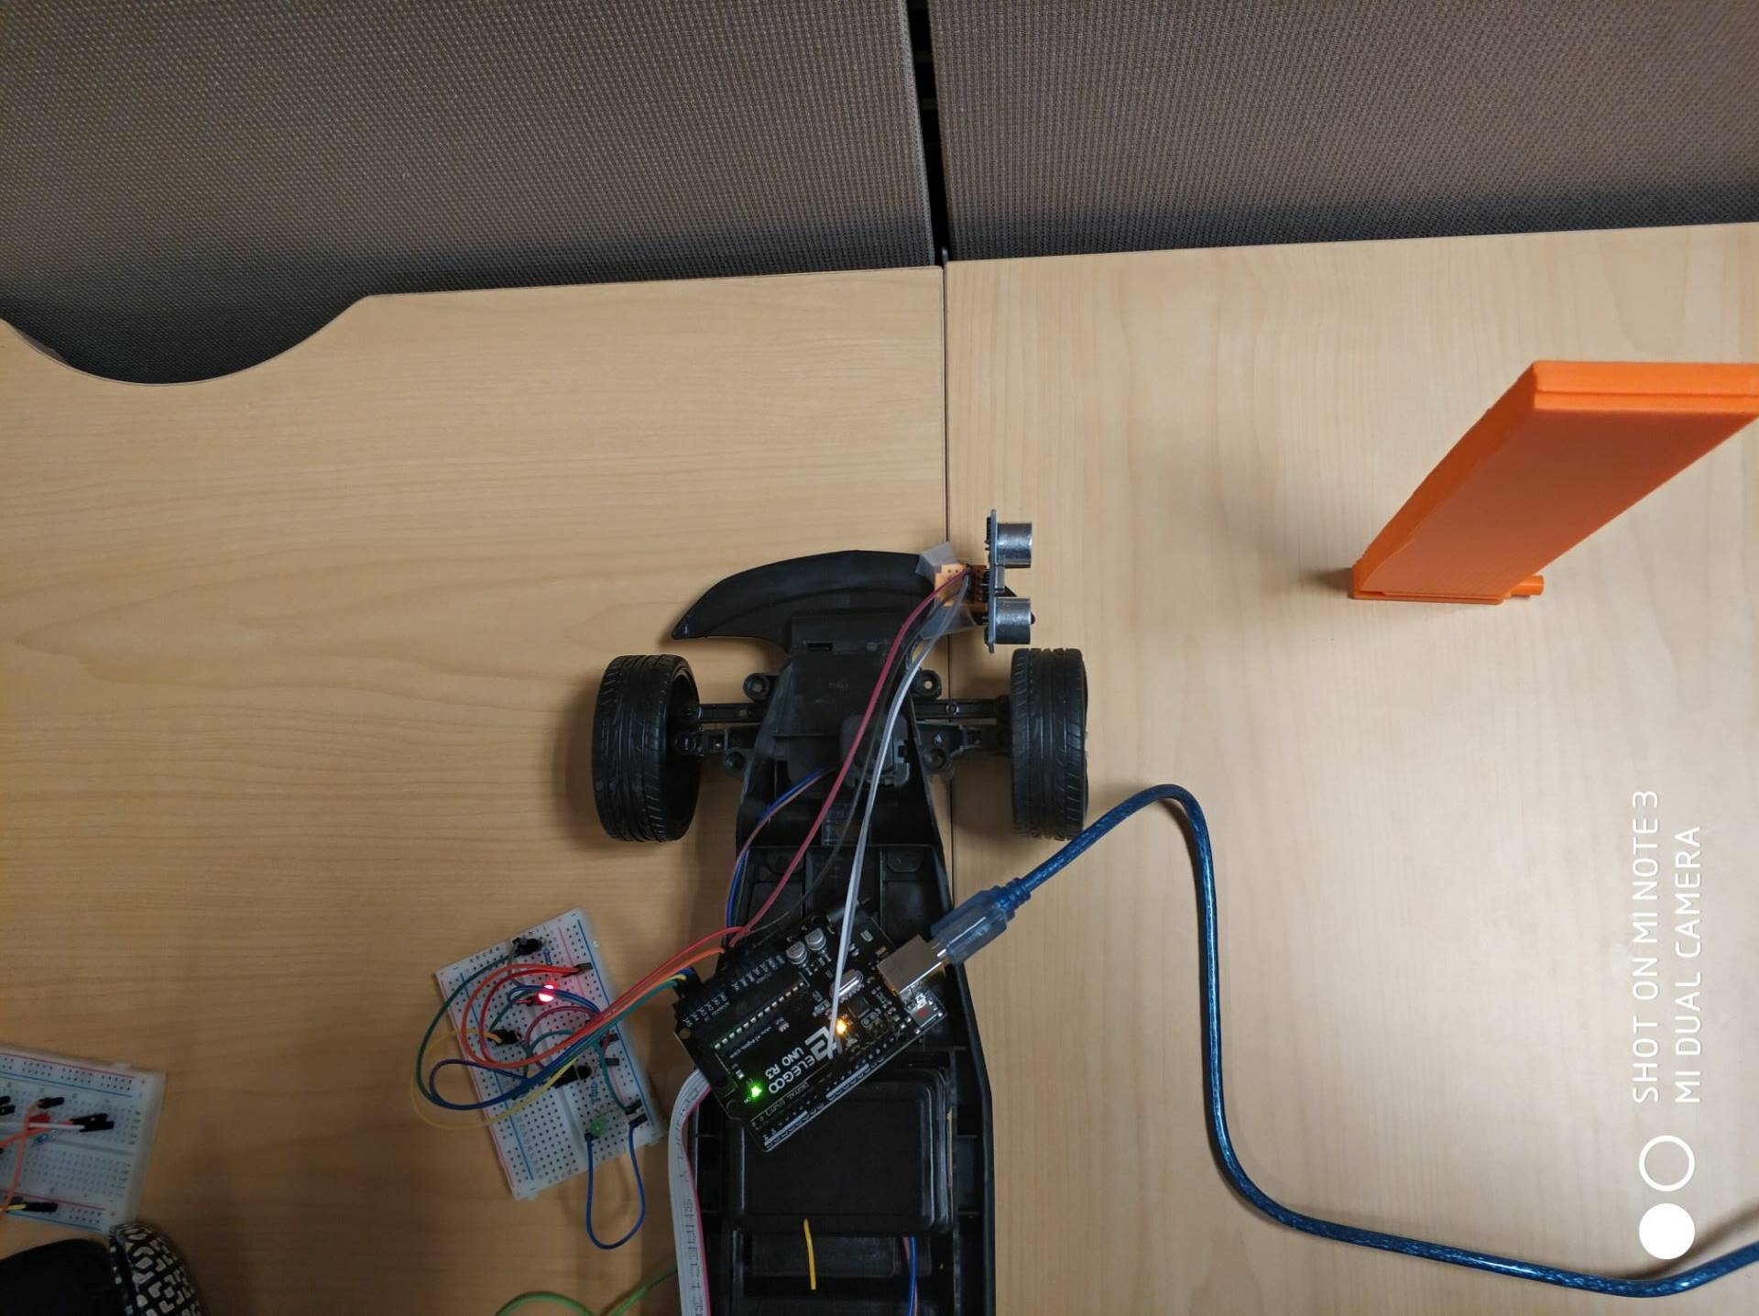

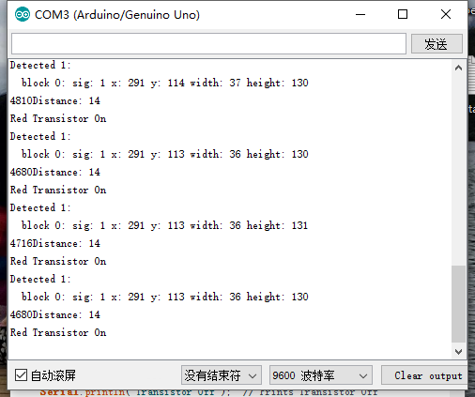

terminal output-RL

this is what pixy sees.

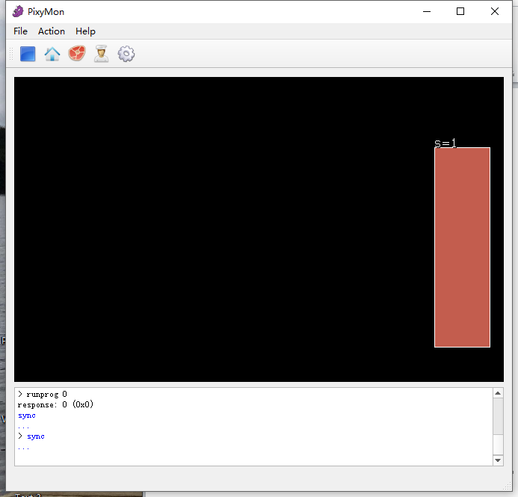

Pixy cam vision-RL

## edge situation

When the distance is greater than 19cm, the object moves out of the field of vision of the camera as shown below, in this situation, it will cause bugs.

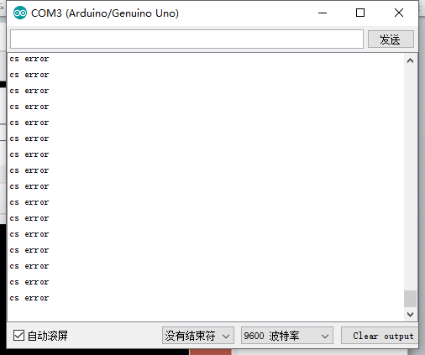

terminal output when >19cm

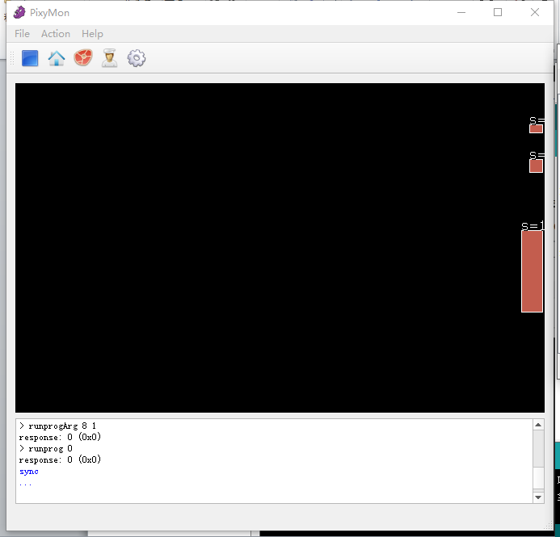

Pixy cam vision when >19cm

When the object moves out of vision totally, the sensor will not record anything.

This is the edge situation, when the distance is equal to 19cm.

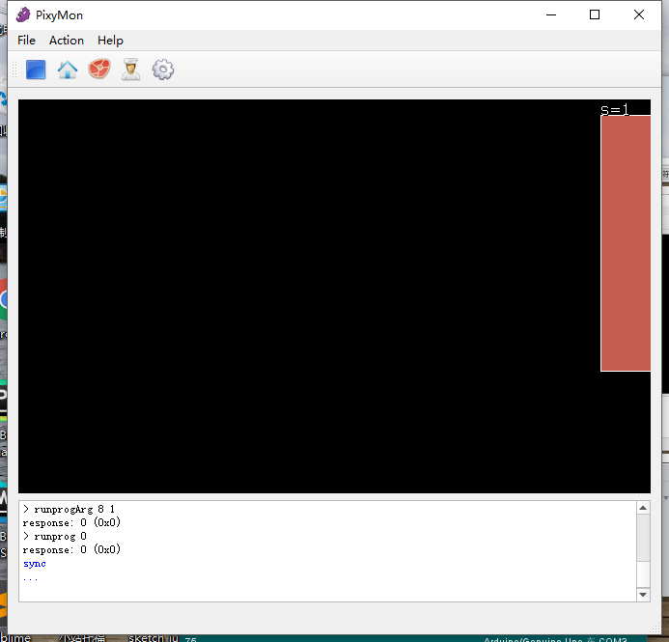

This is the screenshot of the terminal showing the distance output in text.

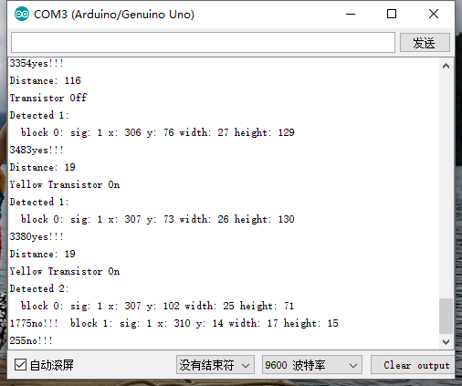

## no recording situation

We can see that the Pixy cam does detect the orange object, at the meanwhile, we put a green object in front of the sensor. The sensor does not open and no light is turned on just as what we think before.

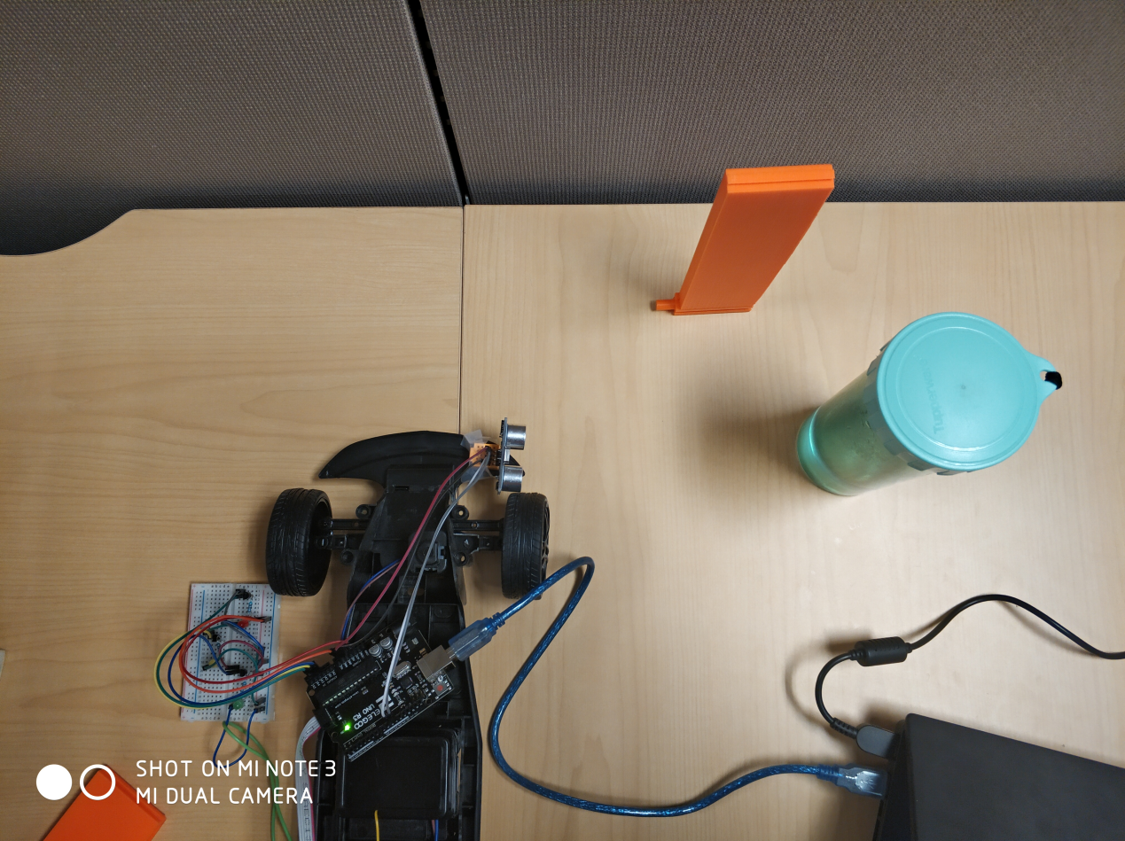

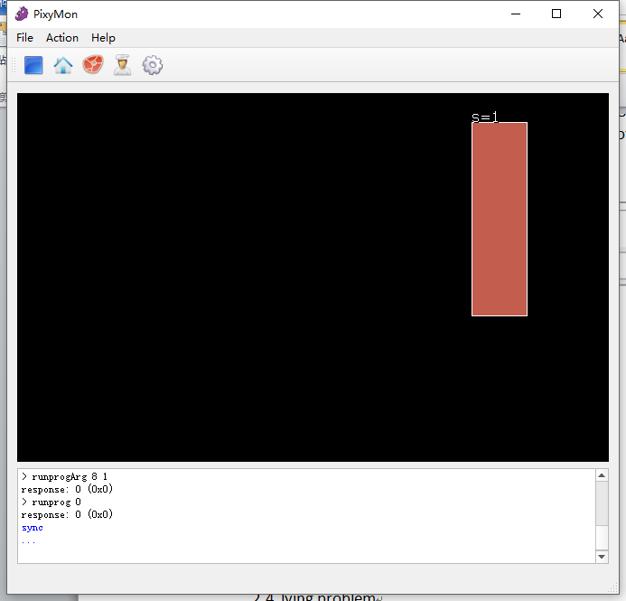

Pixy cam vision

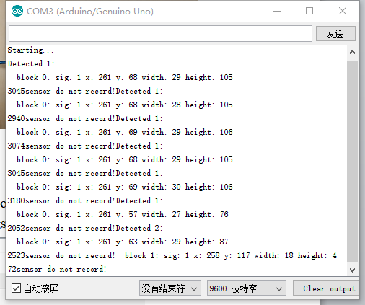

terminal output

## lying object situation

Our system can ignore the lying object and only detect the standing object. When the orange object is lying, the pixy cam can detect it but do not open the sensor and no light is turned on.

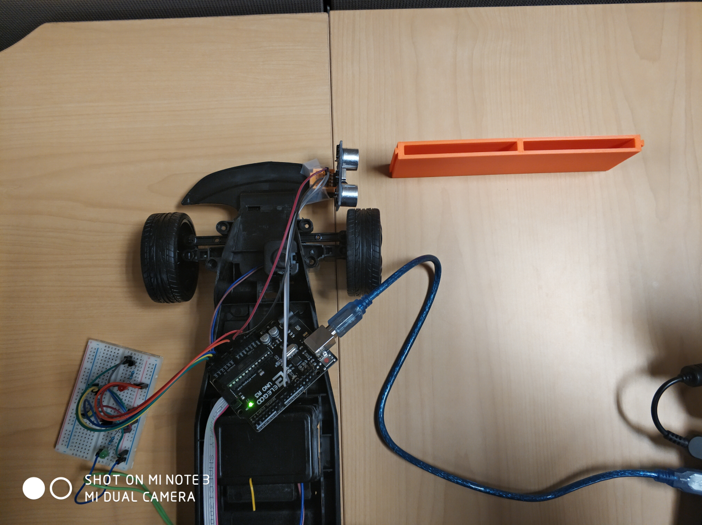

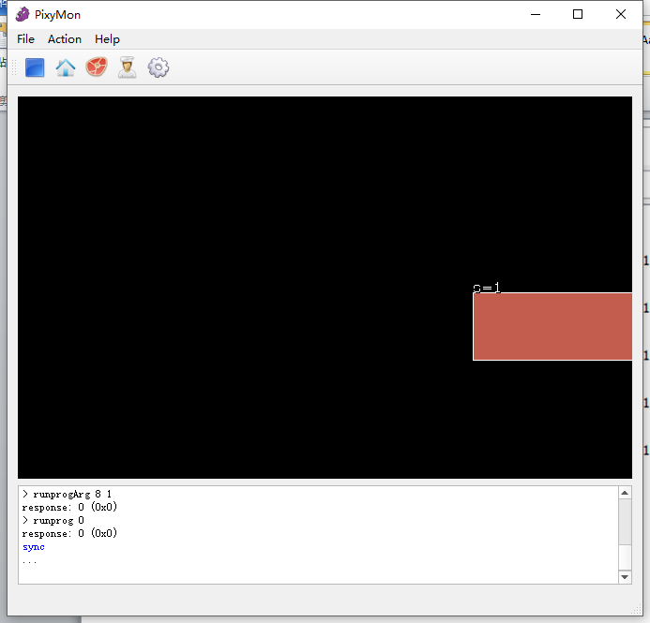

Pixy cam vision of the lying object

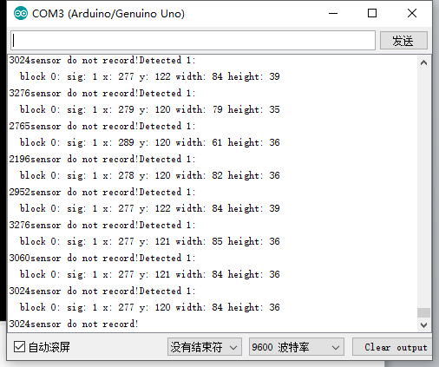

terminal output

# Reference

<https://pixycam.com/pixy-cmucam5/>

<http://www.deviceplus.com/how-tos/arduino-guide/an-intro-to-cmucam5-pixy-vision-camera-sensor/>

http://www.cmucam.org/projects/cmucam5/wiki/Hooking_up_Pixy_to_a_Microcontroller_(like_an_Arduino)